Q: Create a VM and choose resources such as V-net, NSG, NIC, Subnet which are created before hand, then take a snapshot of data disk and attach it to the newly created VM, also create a Custom image of the VM which is provisioned.

1.craete a resource group

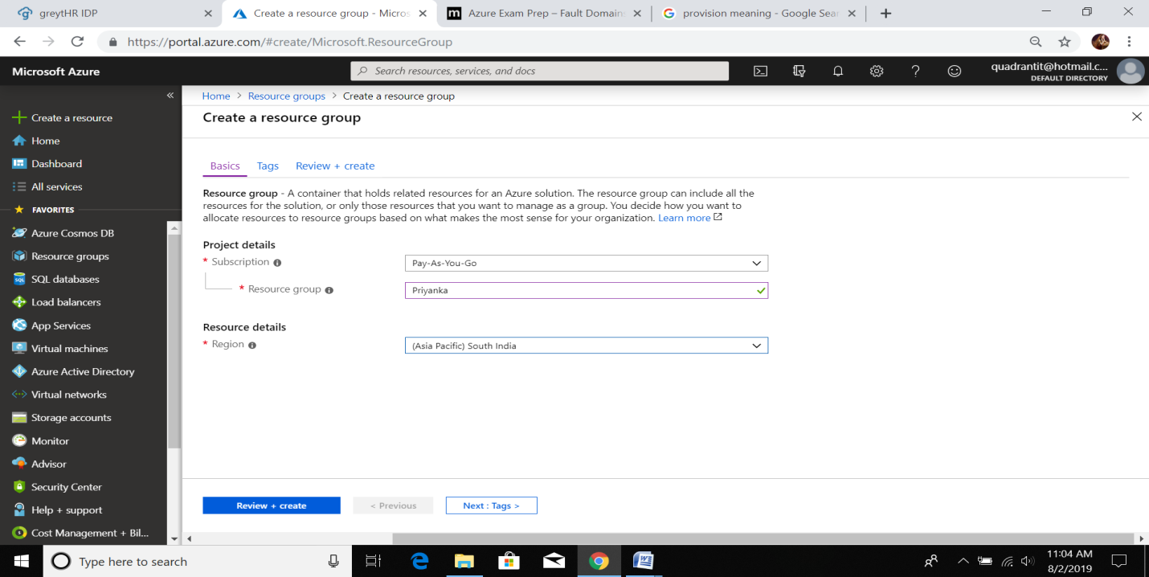

2.crate a virtual network

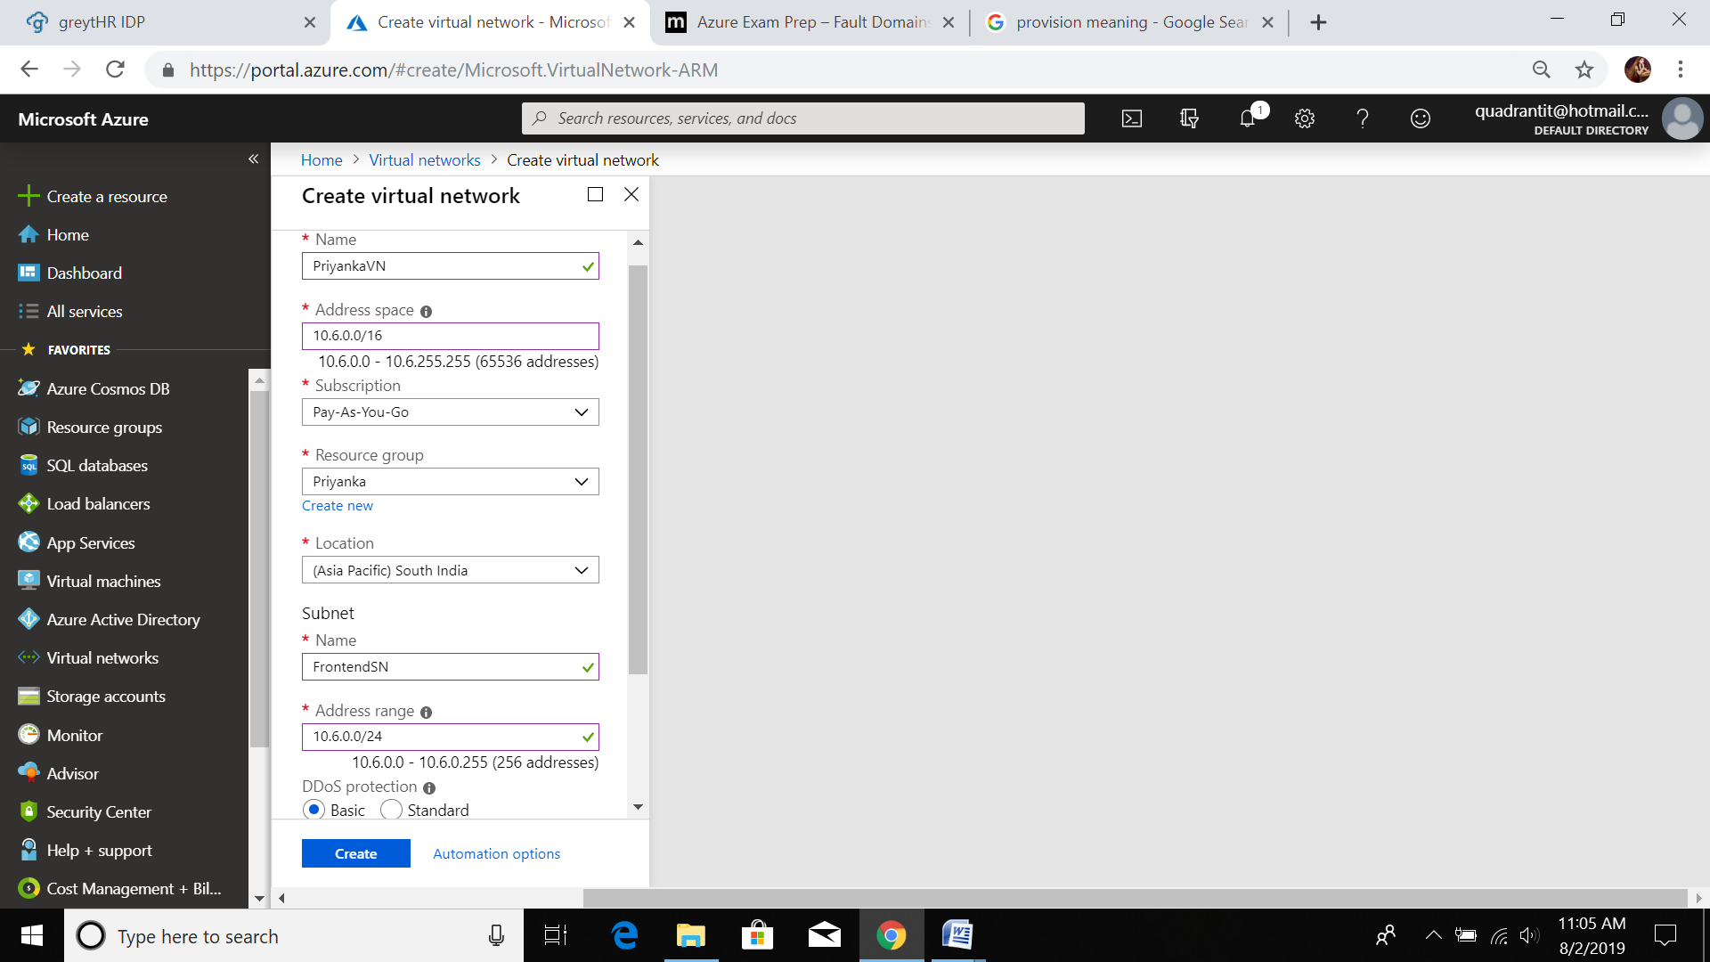

3.create Network security group

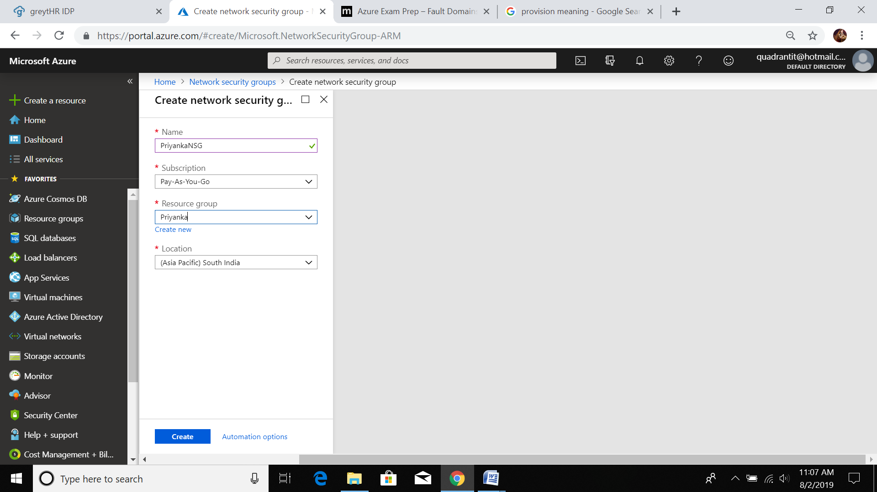

4. create a avalability set with 2 FDs and 5 Uds

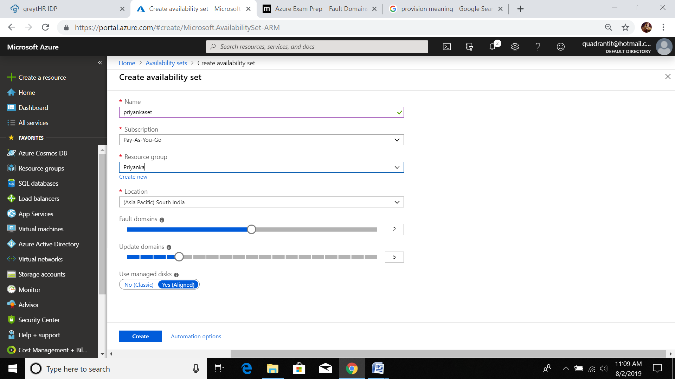

5.now create a Virtual Machine using above resources

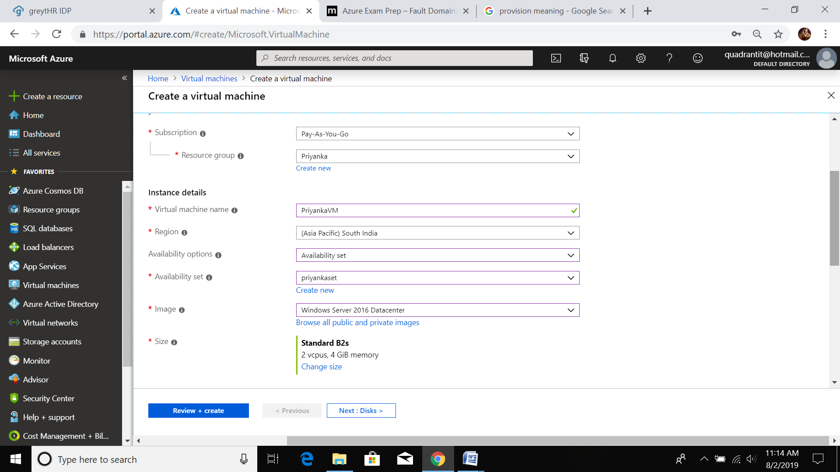

6.create a Disk while creating VM

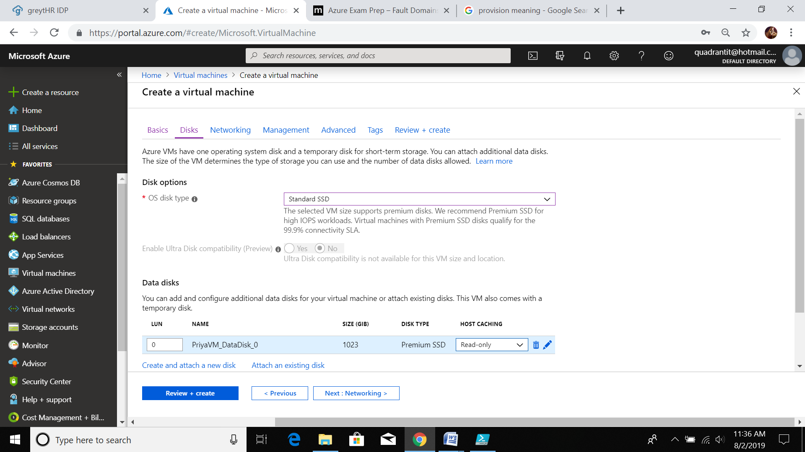

7.VM

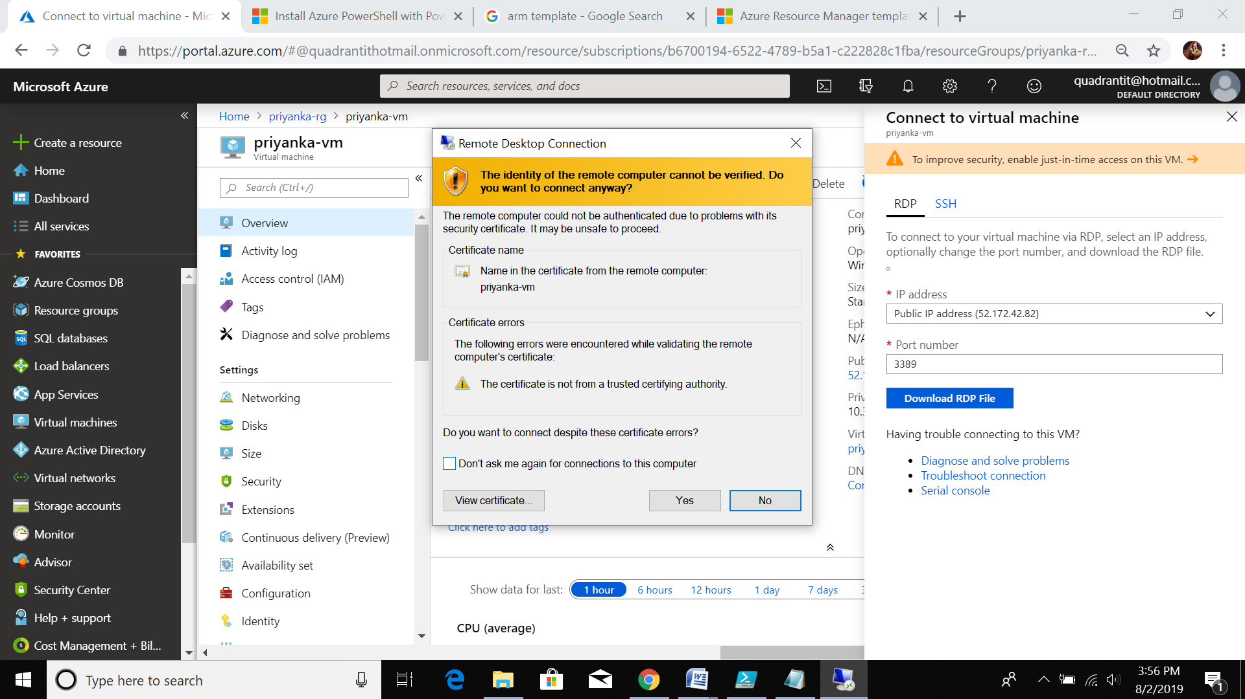

8.SNAPSHOT

* Goto priyaVM -> disk ->opendata disk -> create snapshot

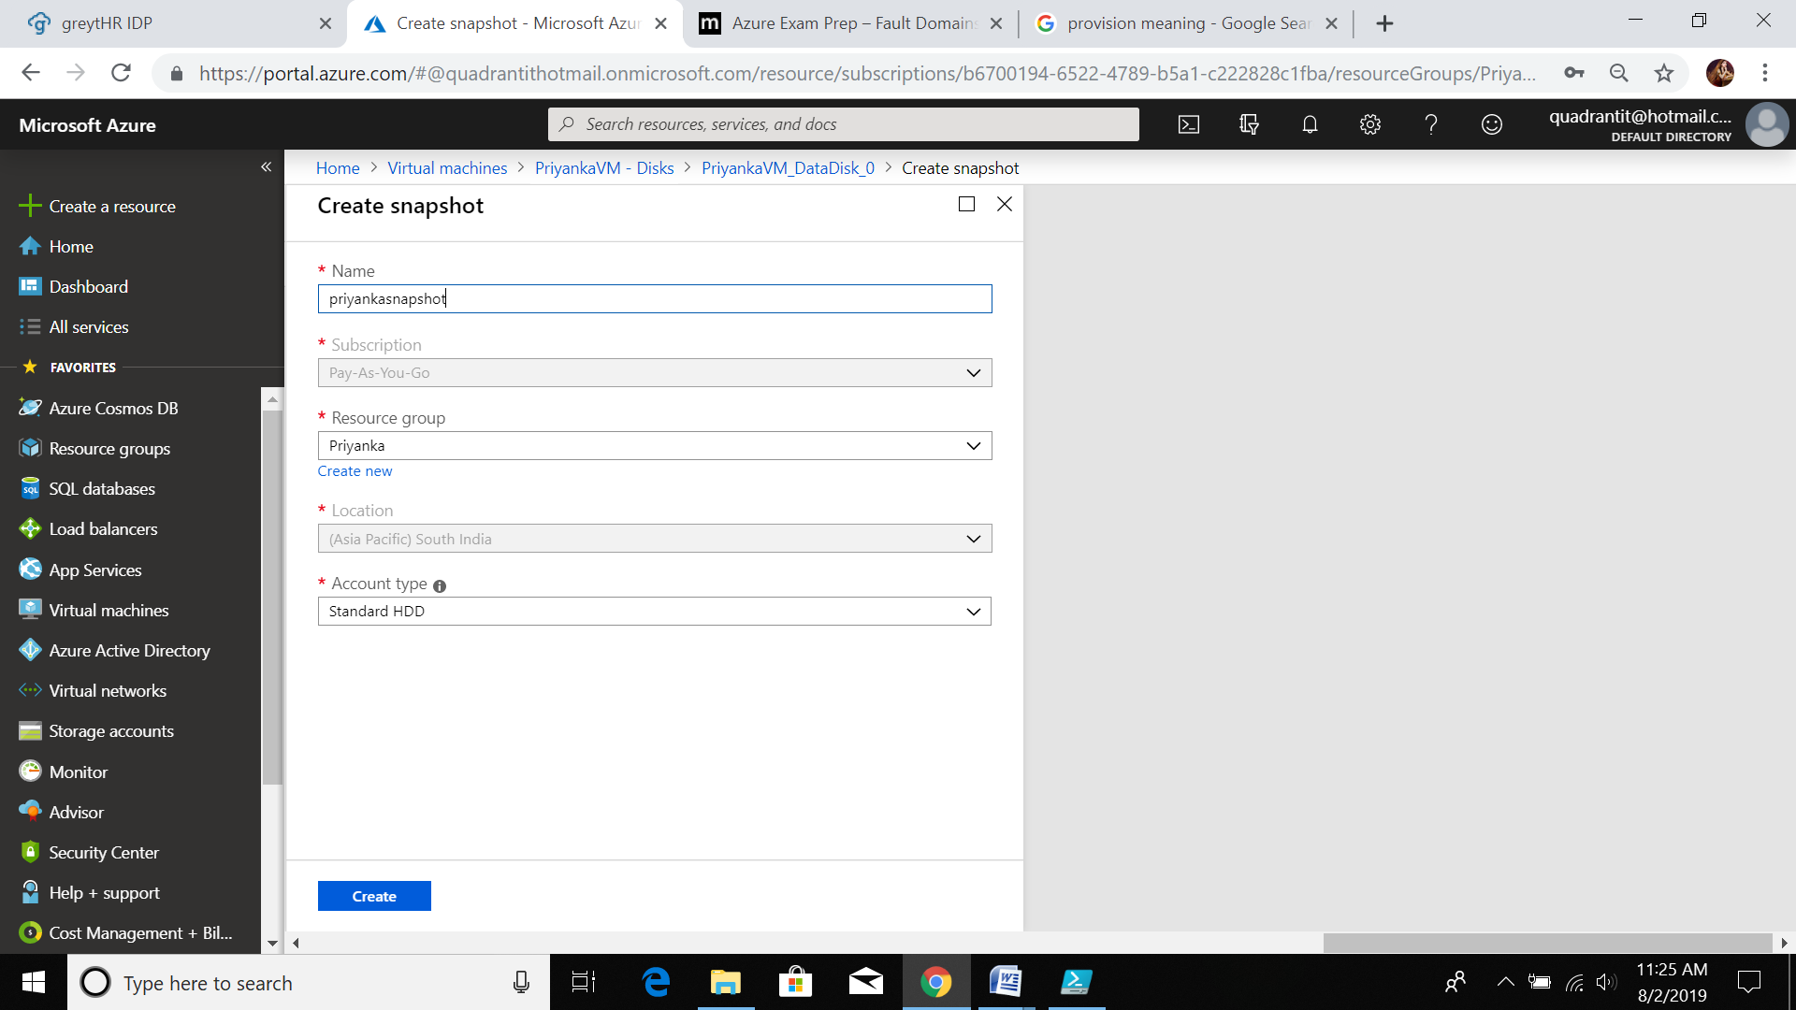

* A **snapshot** reflects the contents **of** a persistent disk **in a** concrete instant in time.
* Now create VM, add above snapshot disk

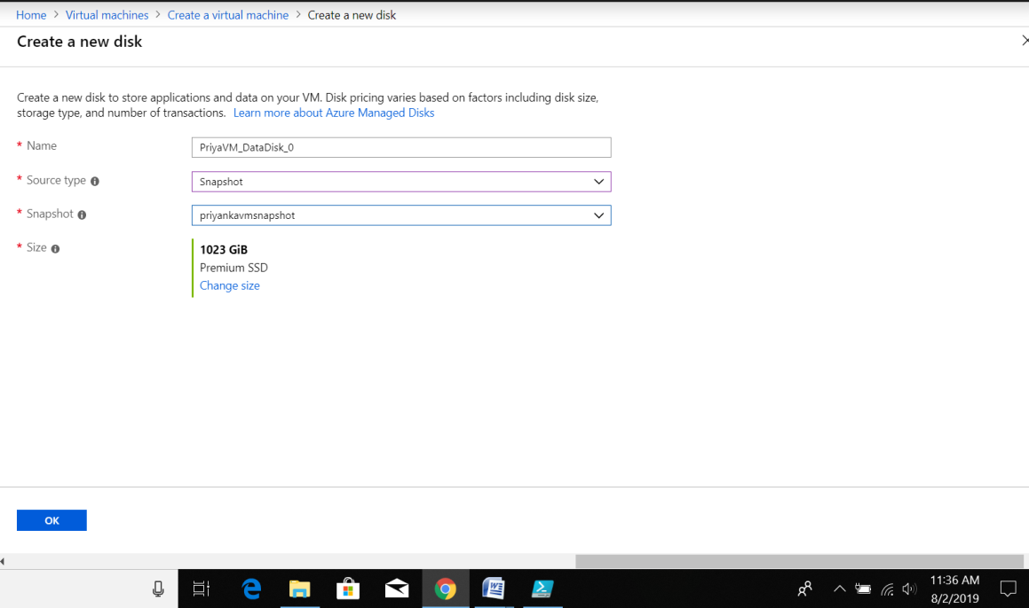

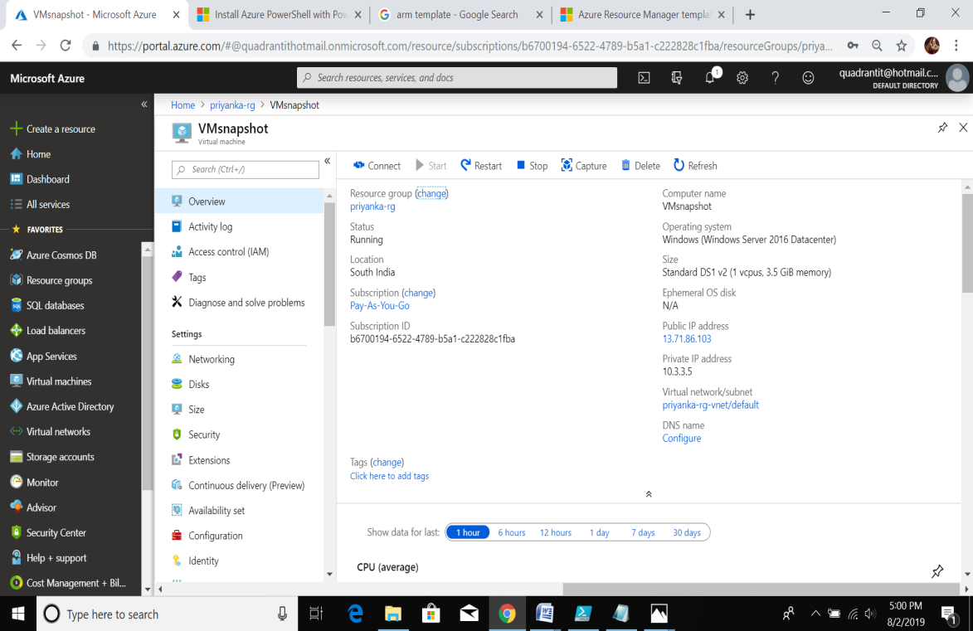

9.VM Image creation

* Connect VM Using RDP file

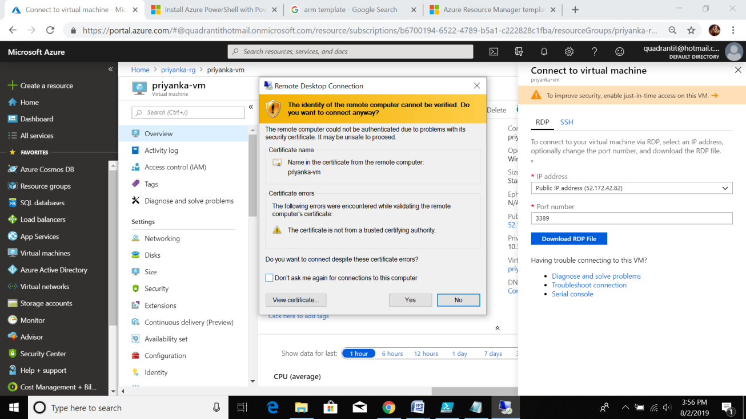

* In VM goto RUN ->sysprep

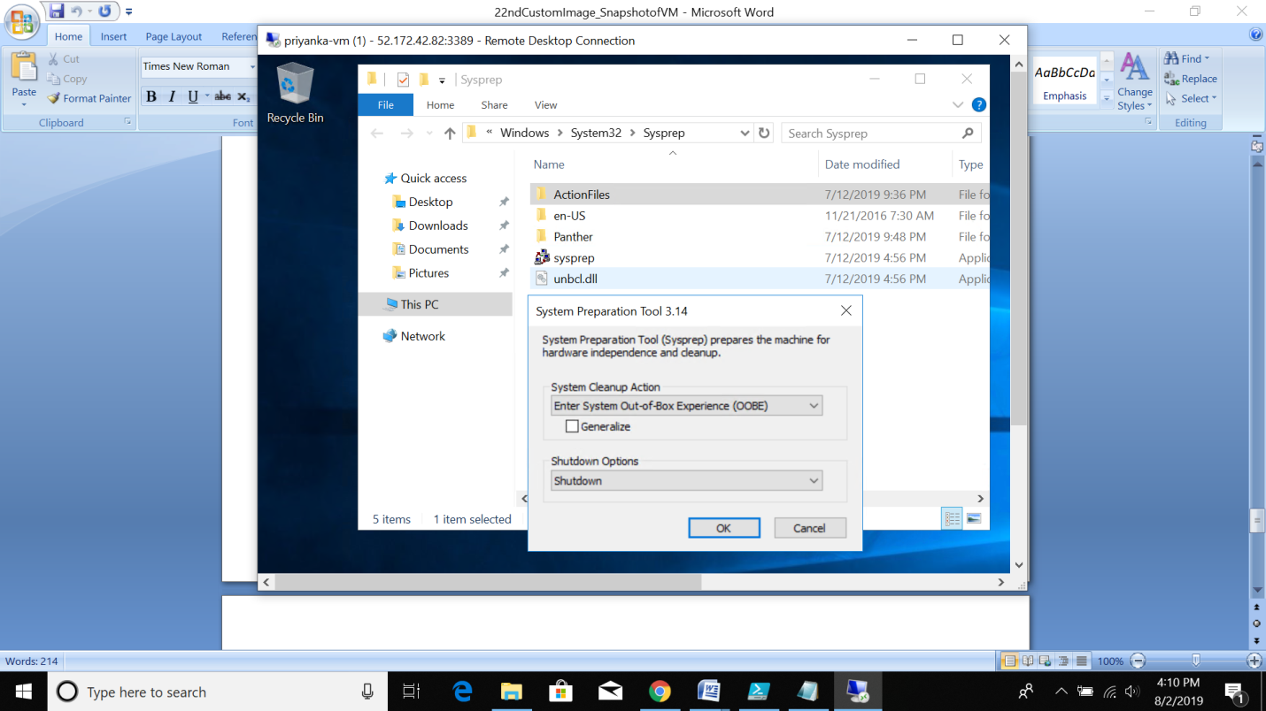

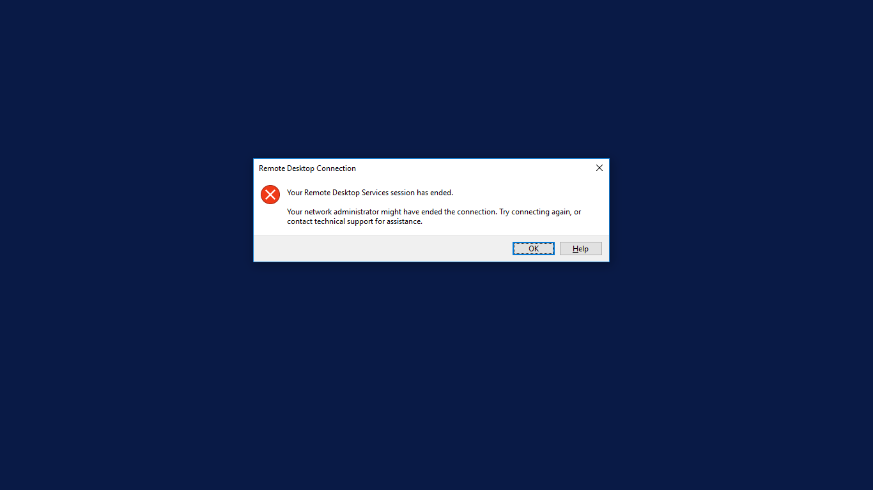

Goto portal->same VM to which we wanted to create image and click on “Capture”(Modify/Change image name if you wish to change)->Check in check box(Automatically detele VM…)->click on Create.

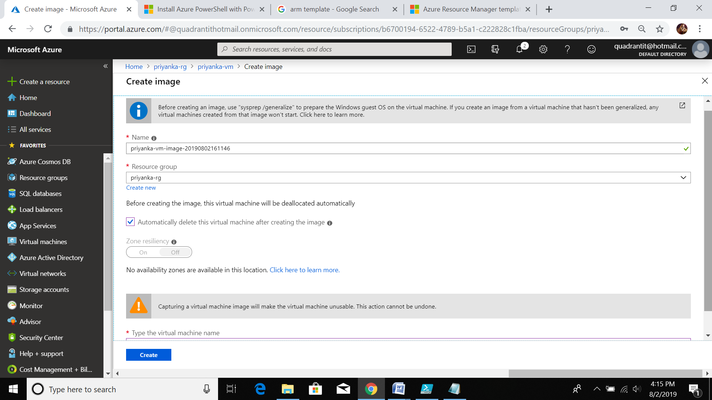

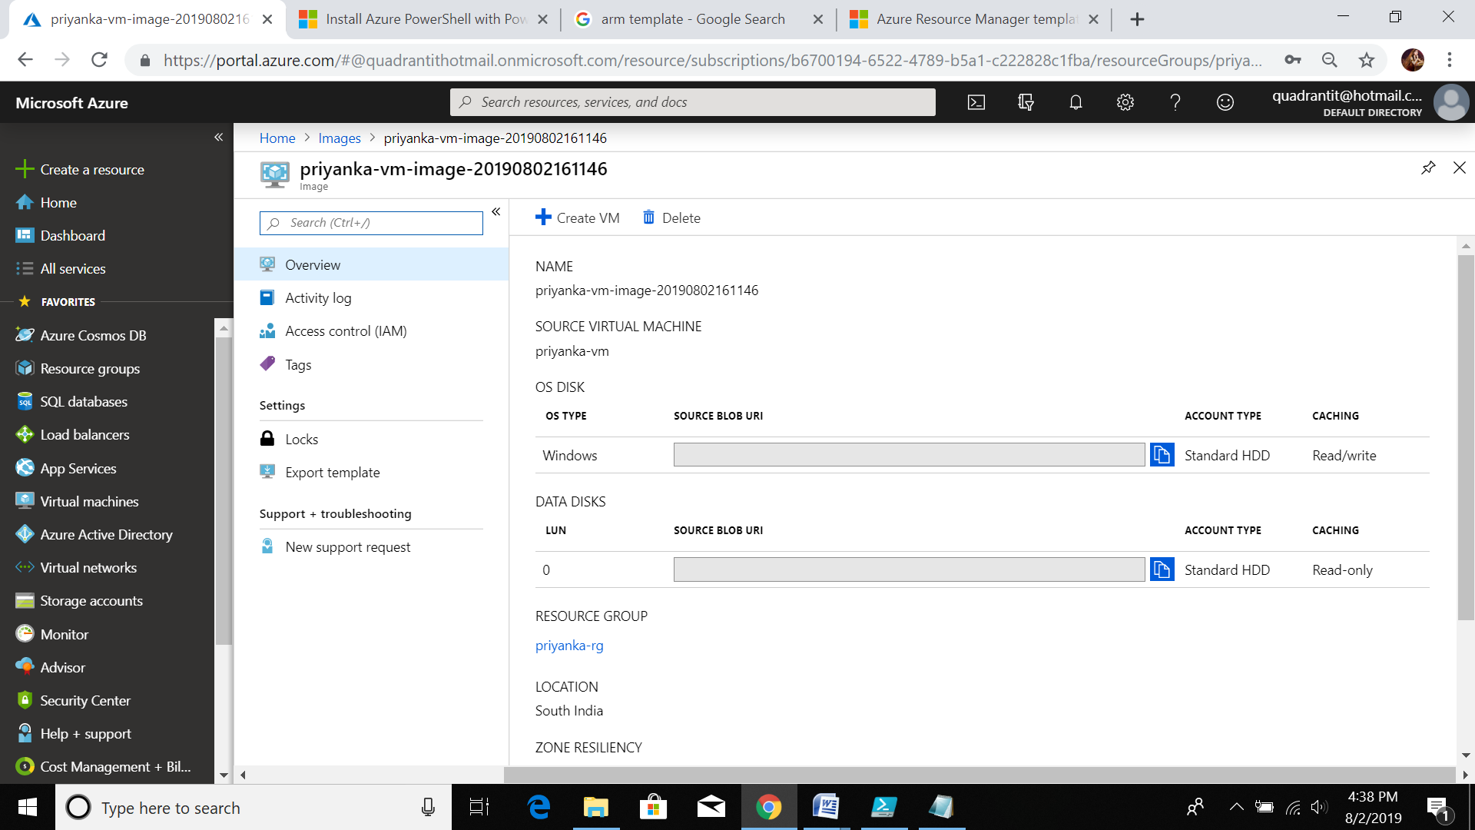

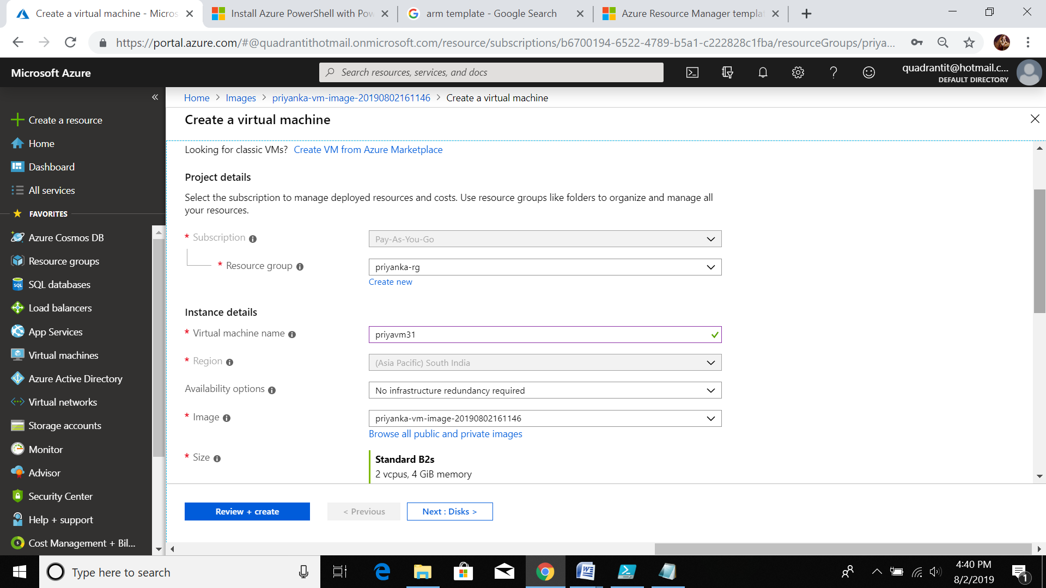

10. this is VM creation using custom domain

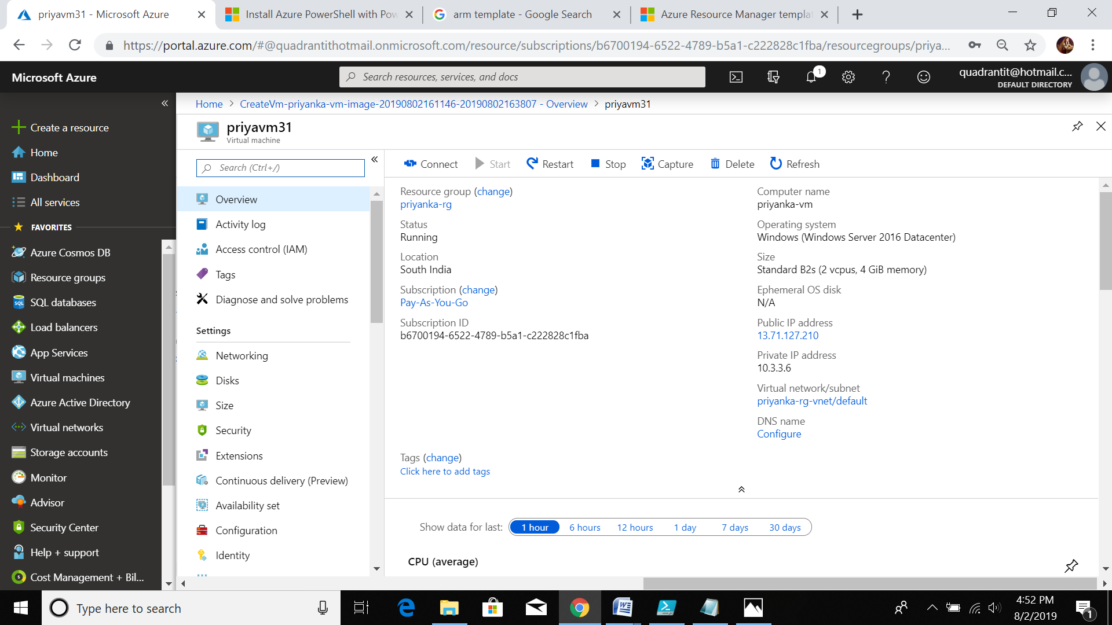

11. this my my resource group with snapshot vm and image

